# Tohorā Southern Right Whale project – some highlights from papers

**Morin et al, 2012: Empirical comparison of single nucleotide polymorphisms and microsatellites for population and demographic analyses of bowhead whales**

**•** 42 linked and unlinked 42 SNPs among 3 bowhead whale stocks

• Tests of population structure (Fst, X2, STRUCTURE), population assignment, population size (Ne), analysis of different numbers of loci and samples to estimate the power of SNPs and microsatellites

• Microsatellites gave greater precision for estimates of Ne and for assignment tests.

** Microsatellites: small pieces of DNA that repeat, only a few letters long. They are useful genetic markers for analysing genome variation, evolutionary processes, etc.

• Assumptions: the four known stock of bowhead whales were considered demographically independent populations

** Genetic linkage is the tendency of DNA sequences that are close together on a chromosome to be inherited together during the meiosis phase of sexual reproduction.

** Linkage disequilibrium (LD) is a population-based parameter that describes the degree to which an allele of one genetic variant is inherited or correlated with an allele of a nearby genetic variant within a given population.

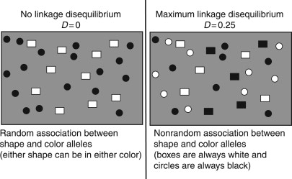

• The sampling location of each sample was defined as the population (BCB, EC, or SO) from

which it was sampled.

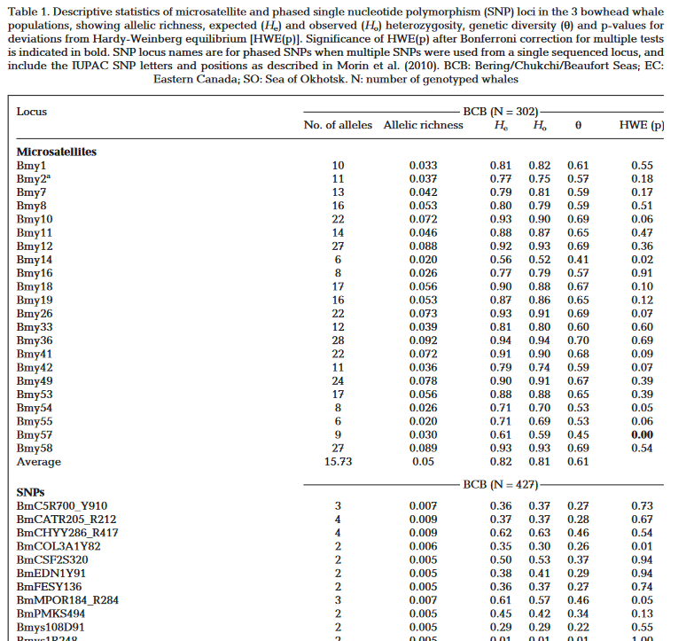

**Carroll et al, 2015: Cultural traditions across a migratory network shape the genetic structure of southern right whales around Australia and New Zealand**

**Fst: fixation index, it measures population differentiation due to genetic structure. It is usually estimated from genetic polymorphism data, such as SNPs and microsatellites.

• Migratory culture: in species with long periods of parental care, preference for breeding or feeding grounds can be transmitted to the offspring.

• Feeding grounds:

WA

SA

VIC

NSW+QLD

TAS

NZ

• These whales followed a large-scale migratory pattern, known as the counter-clockwise pattern: from East to West from Tasmania to Western Australia.

• Mainly female tōhara whales show fidelity to maternally directed wintering grounds

• If mating occurs en route to feeding groups or at them – and whales from distinct wintering grounds do meet in the feeding grounds – then this could decrease genetic differentiation. However, if mating occurs on wintering grounds, to which males and females show fidelity, this can increase genetic differentiation. Mating in the wintering grounds seems to have increased genetic differentiation in NZ, while in Australia the counter-clockwise migration pattern means that distinct populations are meeting in the mating season.

• Hypothesis of this paper:

Migratory fidelity created genetic differentiation between NZ and Australia populations;

There is maternally directed fidelity to feeding grounds, which alters the population structure;

mtDNA is used to provide long-term estimates of the genetic diversity and historical population size of tōhara populations across the South Pacific

• Microsatellite genotype (up to 17 loci) and mtDNA (500bp) were collected around NZ and Australia, as well as stable isotope profiles (δ13 C and δ15N).

• Arlequin v3.5 was used to estimate haplotype (h) and nucleotide (π) diversity for each sampling location. Pairwise F-statistics and hierarchical analysis of molecular variance (AMOVA) were used to compare the differentiation between NZ and Australia feeding grounds.

• Some abbreviations:

Nc: census population size;

Ne(f): effective female population size

Nt(f): number of mature females, which is Ne(f) x 2.

• Migratory culture in the southern right whale seems to be a successful strategy, more than random dispersal. That is because fidelity to the maternal migration route provides more reproductive success and is less risky than adopting a novel route. However, in a time where previously productive feeding grounds can change quickly due to global warming, this could hinder their reproductive success. Such is the case for the Argentinian southern right whales.

• Population of NZ tōhara was of 2,139 whales in 2009 and it seems to be growing 7% per year.

**Jackson et al, 2015 – An integrated approach to historical population assessment of the great whales: case of the New Zealand southern right whale**

• Integrated data sources: 19th century catches, genetic constraints on bottleneck size, individual sightings.

• Pre-exploitation abundance: 28,800 – 47,100.

• After 19th century hunting: 30 – 40 mature females (1914 to 1926).

• Data inputs for the model:

* Bottleneck sizes (Nmin)
* mtDNA haplotypes
* minimum abundance of right whales at the crux of the population bottleneck (Nfloor)
* abundance and population growth data
* annual catch records, already corrected

• Females return to calving grounds every three years to calve, and males showing lower long-term fidelity than females.

• Within the model, annual survival was fixed at 0.97, which is similar to the African right whales model.

• The lower boundary (Nfloor) used to estimate the bottleneck size (Nmin) was based on the number of mtDNA haplotypes surviving in the remnant population, i.e., the minimum possible population size for females.

• The sex ratio was assumed at 1:1.

• Taking the number of haplotypes as a proxy for the number of females, it was then multiplied by 1.5 to account for overlapping generations (i.e., additional females not contributing to the haplotype) and then doubled to account for males. This meant the final number of members of the population was estimated in 3x the haplotype.

• The population model structure is:

N t+1 = Nt · Nt · Rmax ·  - Ct

* Nt is the population abundance in year t
* K is the population carrying capacity in 1827
* Z is fixed at 2.39
* Rmax­ is the maximum population growth rate for the population
* Ct is catches in year t

• Considering all simulations and scenarios, the current NZ recovery rate for these whales is of 7 – 12%, which is below the one found for IWC circumpolar assessment (15 – 20%).

• Based on the Nfloor of 36 and the recovery rate, the population will not be at 95% of its carrying capacity for at least 50 years.

• Apparent annual survival rates of males (a mix of survival and fidelity) was estimated at 0.84, which contrasts to that of 1.0 for females.

**Carroll et al, 2018 – Incorporating non-equilibrium dynamics into demographic history inferences of a migratory marine species**

• Dataset used included mtDNA (n = 1327 – 10% of the current global population) and 17 microsatellite loci (n = 222 – 2% of the global population) from major wintering grounds. The objective was to investigate circumpolar population structure, historical demography and population size.

• Philopatry: fidelity to maternal feeding grounds

• The long and overlapping generation times might have slowed the loss of genetic diversity during the demographic bottleneck caused by whaling.

• Two hypothesis to explain the phylogeographic pattern found on the mtDNA (not muttualy exclusive):

` A) random lineage sorting in a species with continuous gene flow;

B) secondary contact between the formerly isolated populations.

** What is a permutation test used for?

The purpose of a permutation test is to estimate the population distribution , the distribution where our observations came from. From there, we can determine how rare our observed values are relative to the population.

• A few scenarios were tested:

* Scenario 1: Continuous gene flow following population divergence at a single migration rate (MH)
* Scenario 2: Continuous gene flow following two migration rates: one divergence MH and one since the whaling era (MW)
* Scenario 3: Isolation following divergence, with either or no subsequent gene flow
* Scenario 4: Gene flow at one migration rate since the whaling era (MW)
* Scenario 5: Gene flow at one migration rate since the secondary contact (MC)
* Scenario 6: Two migration rates; one since the secondary contact (MC) and one since the whaling era (MW)

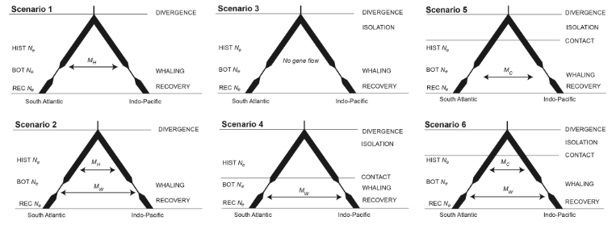

• The timing of these events was fixed at nine generations ago and two generations ago, respectively. An average generation time was estimated at 25 years, and a per-generation mutation rate for the microsatellite loci was estimated at 5 x 10 -4. For each scenario, 100,000 simulations were run and 17 summary statistics were obtained.

• AMOVA analysis indicated greater variation between ocean basins than among wintering grounds within the ocean basins; further analysis showed a strong correlation between ocean basin and genetic cluster. The clustering was stronger when the location was further classified as nursery or wintering ground (K=2 versus K=1).

• The global mitochondrial phylogenetic tree for the species analysed showed distinct clades grouping them into North Pacific, North Atlantic and South Hemisphere individuals.

• The ABC analysis indicated near-zero probability for the demographic scenario with no gene flow (3) and for those with continuous gene flow (1 and 2). Other analysis strongly supported scenarios 4 – 6. Of those, scenarios 5 (one constant migration rate since secondary contact) and 6 (one post-secondary contact and one post-whaling migration rate). best fit the data, with scenario 5 being marginally more supported than scenario 6. It is worth noting that another test could not discriminate between scenarios 5 and 6 about 30% of the time, meaning that the ABC method was flawed when used to discriminate events that happened in the recent pass (<10 generations, i.e., ~250 years).

• In conclusion, the evidence was consistent with the hypothesis that the secondary contact was stimulated by environmental changes that happened in the last glacial maximum (LGM) – such as sea-level rise, which could have impacted the spatial distribution of the wintering habitat, potentially increasing dispersal in the search for better places to calve and socialize.

**Dos Remedios et al, 2021 - Preliminary genomic and isotopic insights from whaling era southern right whale bone from mainland Aotearoa New Zealand**

• Previous global simulations predicted that whaling has led to a 32% to 75% decline in mtDNA richness.

• 18 whale bone samples were analyzed, with 13 allowing for good quality Sanger sequencing; out of those, 11 were southern whale sequences and two were of humpback whales.

• The NZ tohorā population currently uses multiple areas during the winter:

* The primary nursery ground is the Auckland Islands (Maungahuka);
* Campbell Island and some mainland waters are increasingly becoming wintering habitats;

• Their foraging grounds are more widespread, encompassing the East of New Zealand to the South of Australia.

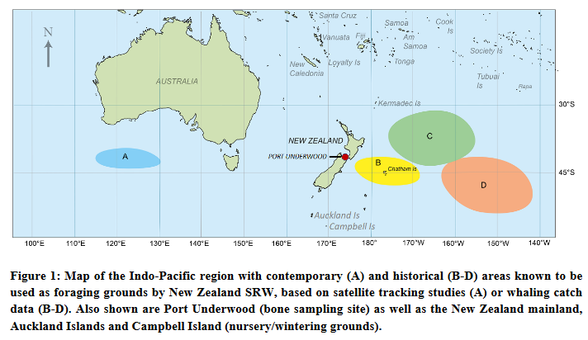

• Studies of the genetics of this species indicate that whales found in these areas form a single interbreeding population, with within- and between-year movement across regions.

• High quality mtDNA sequencing data were obtained for a total of 10 historical SRW samples (Table 1). Nine unique mtDNA haplotypes were present, with only two samples (S012 and S013) exhibiting the same haplotype. Of these nine haplotypes:

* + Two have been observed previously among contemporary southern right whales, One (BakHapE) in the New Zealand, Australian and South African wintering grounds and the other (ValHapEE) in the contemporary Argentinean population.
  + The other seven haplotypes (HistNZA-G) have never before been observed in New Zealand or any other wintering ground among contemporary populations.

• Levels of nucleotide diversity observed among the 10 historical bone samples anayzed were much higher than that of contemporary samples, which suggests a significant loss of genetic diversity and of mtDNA lineages.

• Sequences of historical and contemporary samples differed by an average of 7.9 nucleotides; 11 sites were polymorphic among historic samples only, 4 were polymorphic among contemporary samples only, and eight were polymorphic among both types of samples. No fixed samples were present, which aligns with the hypothesis that the contemporary population is not distinct from, however less diverse, than the historical population.

• Isotope studies showed more negative carbon 13 results for the historical humpback whale collagen, suggesting more time was spent away from coasts and in colder waters foraging for food. In contrast, the historical tohorā was on average more enriched in C13 and marginally more enriched in N15.

• The most common haplotypes in the contemporary population were absent from the historical samples.

**Derville et al, 2023 – Long-term stability in the circumpolar foraging range of a Southern Ocean predator between the eras of whaling and rapid climate change**

